1. The Evolution of Port Royal: From Coastal Hideaway to Global Luxury Destination

SEO Title
The History and Evolution of Port Royal Naples Real Estate

Meta Description
Explore how Port Royal transformed into one of Naples’ most prestigious waterfront communities and why luxury buyers continue investing in this iconic neighborhood.

Target Keywords
Port Royal Naples real estate, Port Royal waterfront homes, luxury homes Naples FL, Port Royal history, Naples luxury real estate

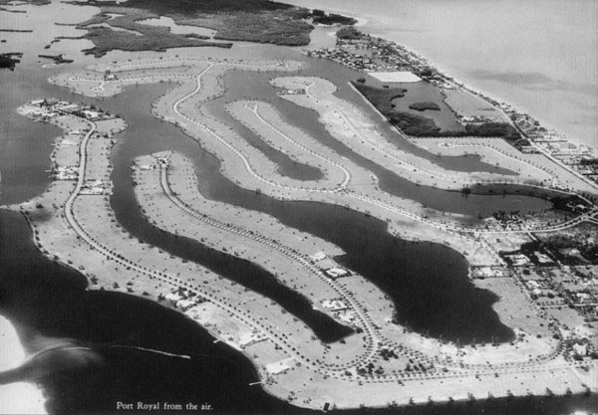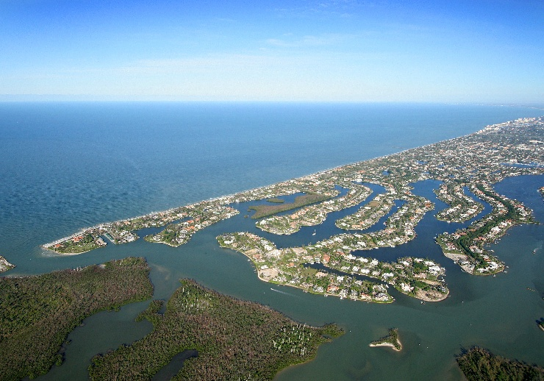

Suggested CTA
Interested in Port Royal real estate opportunities? Contact Michael Giacalone at Premier Sotheby’s International Realty for private market insights and available listings. 239.431.0321

A Neighborhood with a Story Unlike Any Other
Port Royal has become one of the most recognized luxury waterfront communities in the country, but its rise did not happen overnight. What began as a quiet coastal enclave filled with mangroves, canals, and modest waterfront homes has transformed into one of Naples’ most prestigious addresses.
Today, Port Royal represents the pinnacle of waterfront living. The neighborhood attracts buyers from around the globe seeking expansive estates, private dock access, Gulf views, and unmatched privacy. Yet despite its growth into an internationally recognized luxury market, Port Royal has maintained its elegance, charm, and laid-back coastal atmosphere.
One of the defining features of the community is its balance between architectural grandeur and natural beauty. Mature palms line the streets, waterways wind throughout the neighborhood, and many homes are designed to maximize indoor-outdoor living. Residents enjoy boating access to the Gulf of America within minutes, making Port Royal especially appealing for yacht owners and waterfront enthusiasts.
The evolution of Port Royal also mirrors the broader growth of Naples itself. Over the decades, Naples transformed from a seasonal retreat into a thriving luxury destination known for fine dining, golf, boating, arts, and exceptional quality of life. Port Royal remains at the center of that transformation.
For buyers considering luxury real estate in Naples, Port Royal continues to stand out as one of the most desirable waterfront communities in the nation—not only for its homes, but for the lifestyle and legacy that come with ownership.

